**LabManual :Keylogger Using “Spyrix Tool”.**

1. **Goto Windows setting And Search Virus and threat protection and enter , You will see manage setting click on it . A screenshot of a computer

   AI-generated content may be incorrect.**
2. **Turn off all the protections**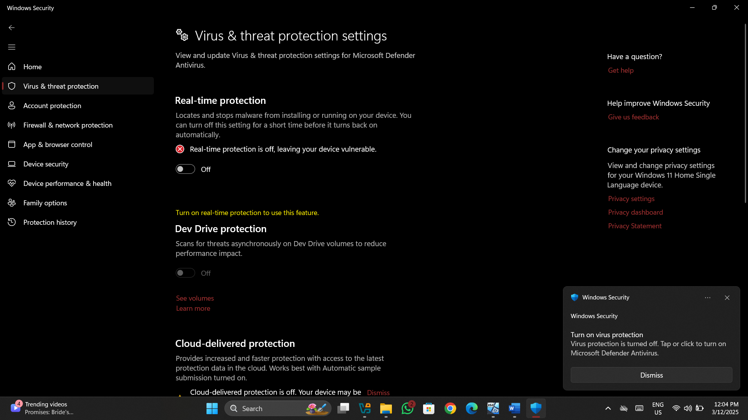
3. **Goto browser and search Spyrix.app .** **A screenshot of a computer

   AI-generated content may be incorrect.**
4. **Click on Download** 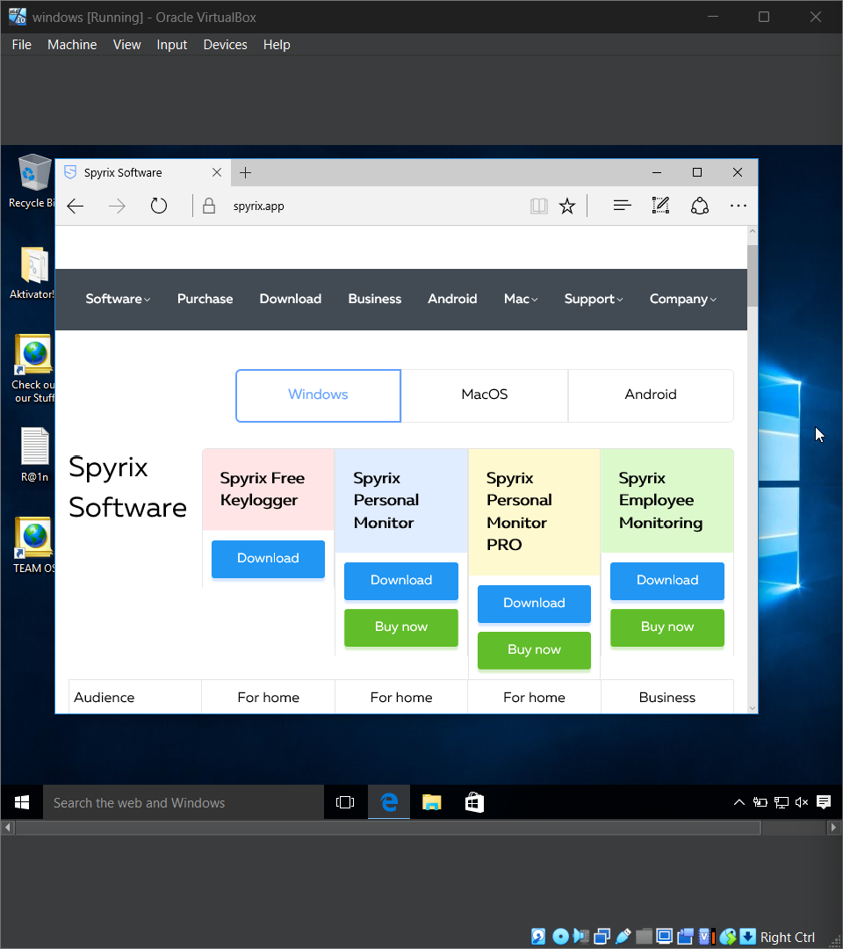
5. **Click on Download spyrix Free KeyloggerA computer screen shot of a computer

   AI-generated content may be incorrect.**
6. **Goto Download And install sfk_setup A screenshot of a computer

   AI-generated content may be incorrect.**
7. **You will see this window click on more info and run anyway**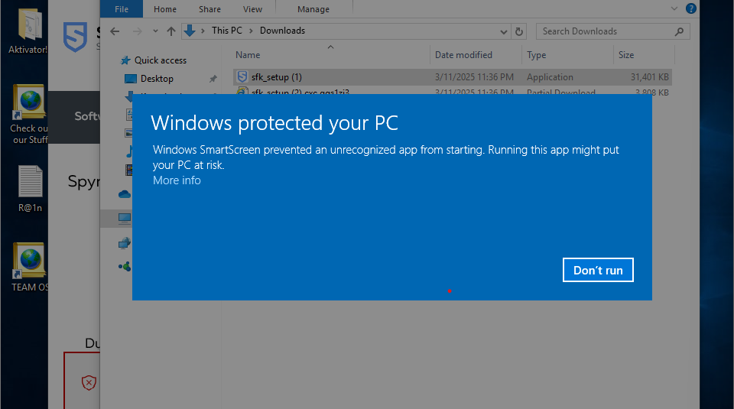
8. **Click on OkA screenshot of a computer

   AI-generated content may be incorrect.**
9. **Enter any Email address and click next**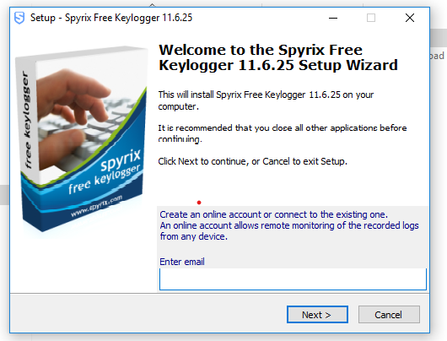
10. **Give any Password that You wnts to give and click create**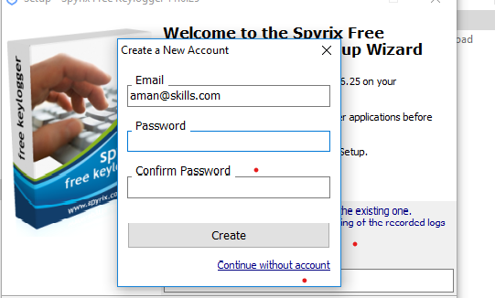
11. **Click on I accept and next then install and finish**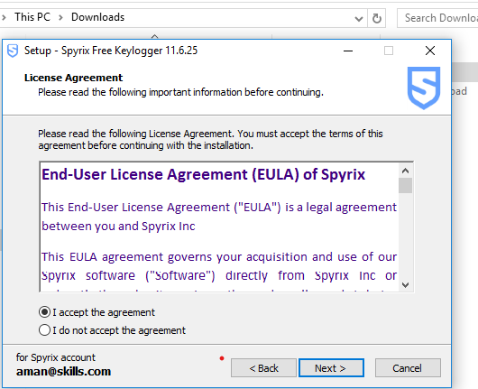
12. **Your installation has been Completed .**
13. **Now goto your Browser And search spyrix.com and click on my account**

1. **Login with the same email and password which you have given while creating an account** 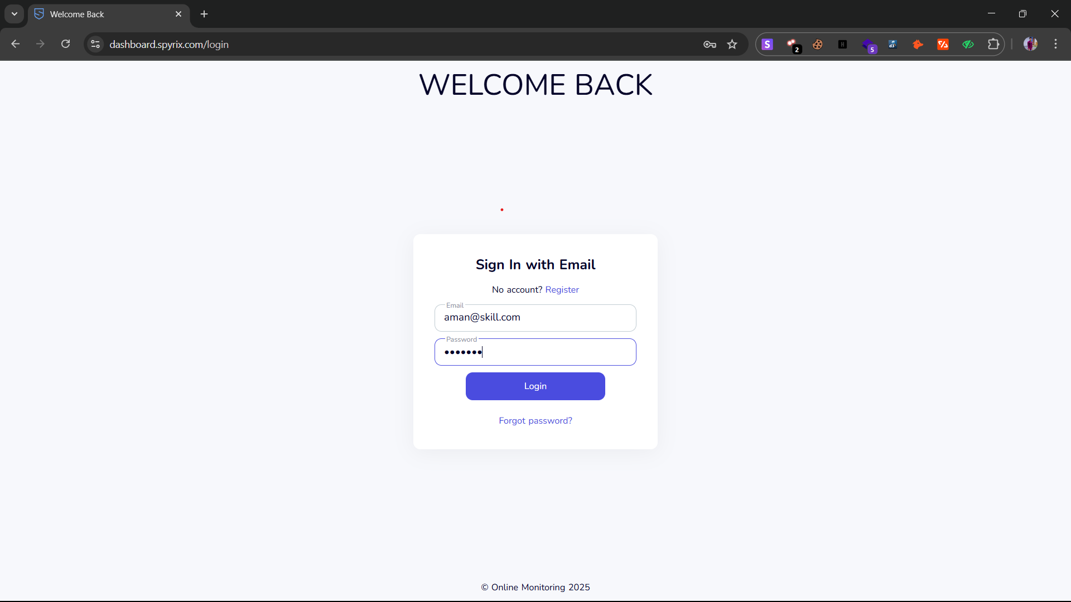
2. **Now yu will be able to Monitor Victim’s Device.** 